New Partner Opportunity: Join the Regional Partner Network
We are actively expanding our Regional Partner Network and onboarding qualified resellers, agencies, consultants, and business service providers across multiple growth markets.
This is your chance to position yourself early within a rapidly growing ecosystem built around AI‑powered business automation, payments, POS, CRM, e‑commerce, customer engagement, and operational management solutions. Businesses are actively seeking modern unified platforms, and partners who establish themselves now will be best positioned to capture demand as adoption accelerates.

Benefits for Regional Partners
- Access to recurring revenue opportunities
- Onboarding and sales support
- Training resources and partner incentives
- Scalable solutions to grow long‑term client relationships and increase retention
As expansion continues across new regions, early partners gain the advantage of establishing local presence, building market recognition, and securing client relationships ahead of increasing competition. The strongest opportunities will go to partners who move quickly, build momentum early, and actively develop their territories.
👉 If you are looking to grow your business with a high‑demand platform and participate in a rapidly expanding partner ecosystem, now is the time to join the Regional Partner Network and position yourself for long‑term growth.

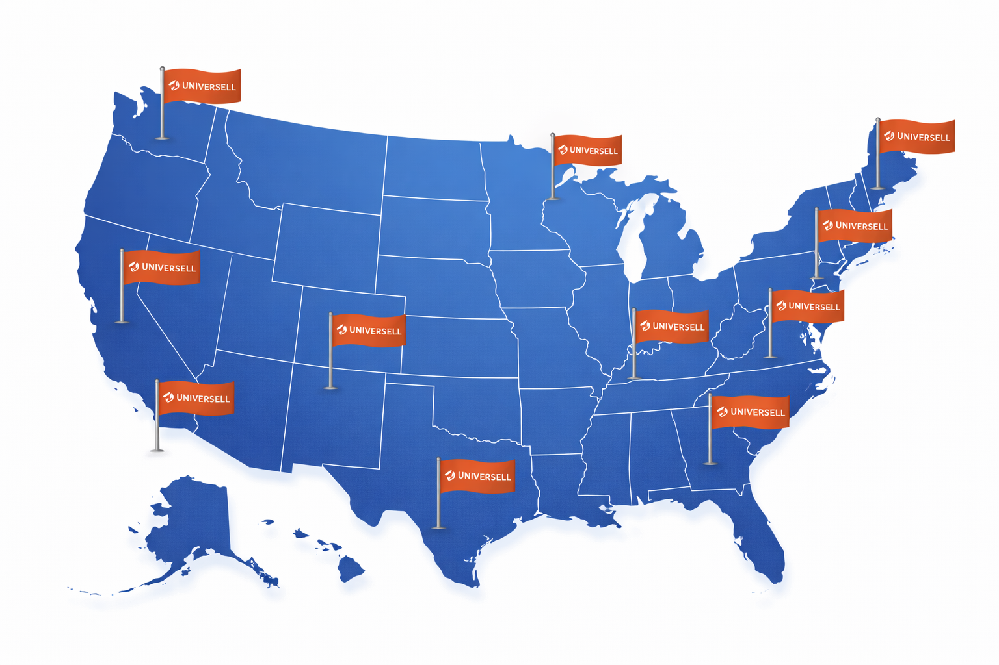
Map - with Universell Flags

🟣 Certified Implementation Partner Program

Become a Certified Implementation Partner
Join Universell’s premium tier - reserved for vetted professionals and agencies who deliver proven results.
✔ Certification requiredThe information is not visible to add interest.
✔ Profile page with branding & portfolio
✔ Featured placement in the directory
✔ Access to qualified leads
Revenue Opportunities:

- Revenue Share the info is not visible to add interest
- System Implementation the info is not visible to add interest
- AI Implementation the info is not visible to add interest
- Saas Plan fees the info is not visible to add interest
Schedule a meet to learn more

Video Testimonials
Watch Partner Stories
https://app.heygen.com/videos/avatar-video-f2ec187cc23545b0b8789059e43a1ef8

CTA: [Apply for Certification] [View Partner Directory]

🟠 - Affiliate Partner Program
Create a serious looking symbol for Affiliate Partners another for Implementation Partner
Affiliate Partners - Recommend & Earn
join and earn by referring clients to Universell.
Work with a top business growth platform geared to helping businesses win!
✔ More than AI prompts. Recommend a growth platform leveraging an orchestration of AI, business management infrastructure and growth tools
No onboarding or support required
✔ Universell handles fulfillment
✔ Commission for every successful referral
Finder’s Fees:
Flat or percentage‑based compensation for referrals outside your core product offering.
CTA: Schedule a meet to learn more

